ASSIGNMENT -2

**1. Update Your Watch list:**

**1.1 Add the following asset classes to your watch list on both your trading platform and**

**Trading View:**

a) Major Currencies (5)

b) Cross Currencies (5)

c) Exotic Currencies (3)

d) Commodities (3)

e) Cryptocurrencies (3)

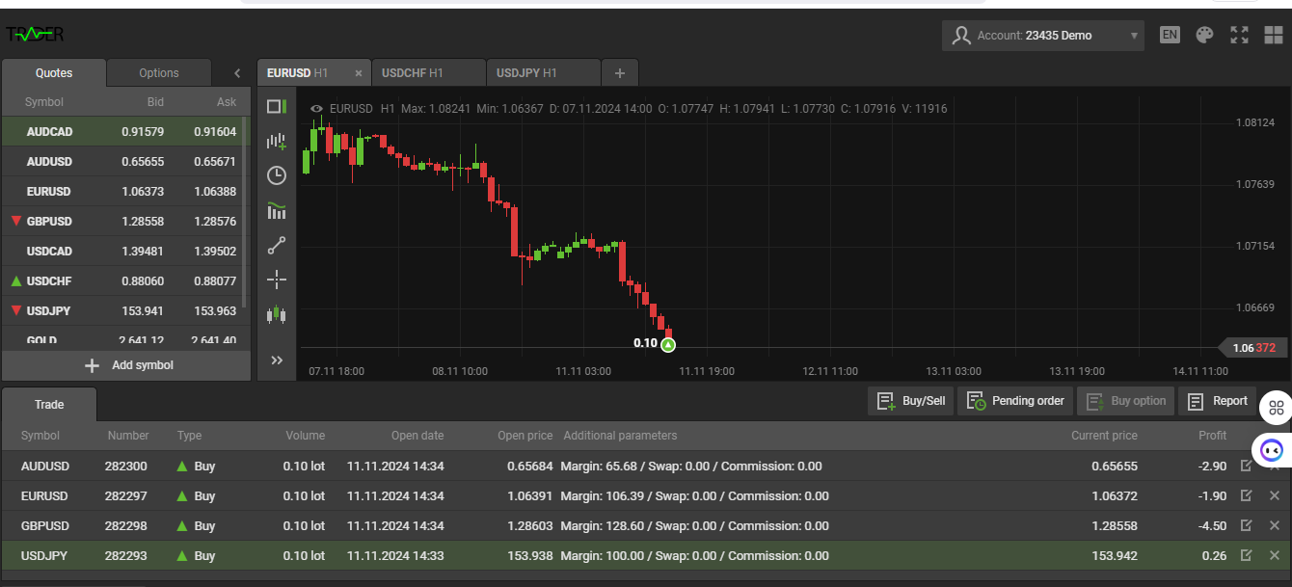

**Case Study 1: EUR/USD Currency Pair**

1. **Given Information:**
   * Entry price: 1.08426
   * Exit price: 1.08526
   * Units (or lot size): 100,000 (1 standard lot)
   * EUR/USD is quoted to the fifth decimal, so 1 pip = 0.0001.
2. **Calculations:**

**a) PIPs Calculation:**

* + Pips = (Exit price - Entry price) / Pip value
  + Pips = (1.08526 - 1.08426) / 0.0001
  + Pips = 0.00100 / 0.0001 = 10 pips

**Answer:** The profit is **10 pips**.

**b) Dollar Profit Calculation:**

* + Dollar profit = Pips × Lot size × Pip value in USD for 1 standard lot
  + For EUR/USD, 1 pip for 1 standard lot (100,000 units) is $10.
  + Dollar profit = 10 pips × $10
  + Dollar profit = $100

**Answer:** The profit is **$100**.

**Case Study 2: USD/JPY Currency Pair**

1. **Given Information:**
   * Entry price: 149.777
   * Exit price: 149.577
   * Units (or lot size): 10,000 (1 mini lot)
   * USD/JPY is quoted to the third decimal, so 1 pip = 0.01.
2. **Calculations:**

**a) PIPs Calculation:**

* + Pips = (Entry price - Exit price) / Pip value
  + Pips = (149.777 - 149.577) / 0.01
  + Pips = 0.200 / 0.01 = 20 pips

**Answer:** The profit is **20 pips**.

**b) Dollar Profit Calculation:**

* + Dollar profit = Pips × Lot size × Pip value in USD for 1 mini lot
  + For USD/JPY, 1 pip for 1 mini lot (10,000 units) is approximately $1.
  + Dollar profit = 20 pips × $1
  + Dollar profit = $20

**Answer:** The profit is **$20**.

**Case Study 3: XAU/USD (Gold/USD) Commodity Pair**

1. **Given Information:**
   * Entry price: 2361.04
   * Exit price: 2376.04
   * Units (or lot size): 10 troy ounces
   * For XAU/USD, 1 pip = 0.01, and 1 tick movement is usually 0.1.
2. **Calculations:**

**a) Ticks and PIPs Calculation:**

* + Price difference = Exit price - Entry price = 2376.04 - 2361.04 = 15.00
  + Ticks = Price difference / Tick size = 15.00 / 0.1 = 150 ticks
  + Pips = Price difference / Pip value = 15.00 / 0.01 = 1500 pips

**Answer:** The profit is **1500 pips** or **150 ticks**.

**b) Dollar Profit Calculation:**

* + Dollar profit = Price difference × Lot size
  + Dollar profit = 15.00 × 10 (since the trader bought 10 troy ounces)
  + Dollar profit = $150

**Answer:** The profit is **$150**.

**Case Study 4: BTC/USD Cryptocurrency Pair**

1. **Given Information:**
   * Entry price: 67,544
   * Exit price: 67,300
   * Units (or lot size): 0.1 BTC
   * BTC/USD is quoted in whole dollars, so 1 pip = 1.
2. **Calculations:**

**a) PIPs Calculation:**

* + Pips = (Entry price - Exit price) / Pip value
  + Pips = (67,544 - 67,300) / 1
  + Pips = 244 pips

**Answer:** The profit is **244 pips**.

**b) Dollar Profit Calculation:**

* + Dollar profit = Price difference × Lot size
  + Dollar profit = 244 × 0.1
  + Dollar profit = $24.40

**Answer:** The profit is **$24.40**.